Whole Numbers and Base Ten Structure Stem Lesson Ladder

PROGRESSION
Essential Foundational Knowledge (Roots) | - Counting with a fixed unit; 1 to 1 matching; “how many” is determined by pairing, counting, subitizing  - Numerals 0-9  - Composing/decomposing within 10
Leads to | - Standard algorithms for addition, subtraction, multiplication, division explained by place value and properties (commutative/associative/distributive) and renaming across places  - Fluency with ×/÷ by 10^k and with powers of ten  - Extension of place value to the right of ones (finite decimals) after the fractions stem is in place
Big Ideas | - Patterns and structure of base ten place value system  - Digits have value based on position in a number  - Flexibility with numbers (representing numbers in different forms)  - Relationship between place value units is multiplicative  - Applications of place value understanding (comparing/ordering, rounding, and in other stems, operations)  - Decimal notation (and the connection between decimal fractions and decimal numbers)
Other Information | - Students will cycle through these concepts/skills multiple times as additional place value units are introduced  - The Counting Array, which is embedded in multiple concepts/skills, becomes a mental image, just like the number line  - Unit form is a bridge, not core; the core representation is multiplicative expanded form (digits $×$ place value units).  - When using place value charts, connect them explicitly to either the counting array or the number line or expanded form. Place value charts can organize work, but equations, expressions, and number line are the most important mathematical representations  - CAUTION: decimal work is grounded in fractions, and students need understanding of “decimals” as “a funny way to write a particular kind of fraction” before they can tackle the decimal place value units through this stem. This matters because finite decimals need logical sequencing: before we can make mathematical sense of complete expanded form for decimals, students need fraction addition and decimal fractions in place. Don’t discuss extended decimal place value without first grounding fractions/decimals properly.  RE counting array:  - Use counting array to establish the structure of two- and three-digit whole numbers. And that this structure has a very utilitarian (and genius!) human purpose  - Fade toward expanded form and number line as numbers get large.  - Do not use counting array for decimal place value.

Concept/Skill:

Use place value to read and write numbers.

Goal | Understand what each digit in a number represents
Student-Facing Example | 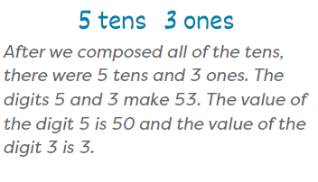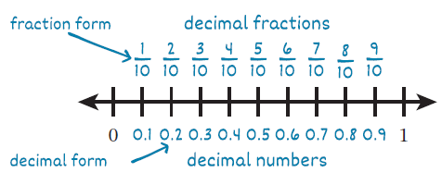
Knowledge Graph Node | Identify place value units and understand that each one is composed of ten of the next smaller unit. | Determine the value represented by each digit of a number. | Read and write numbers in standard form. | Read and write numbers in word form.
Terminology | - Place value is a way of writing down numbers that lets us write down any whole number using only ten different symbols.  - A place value unit is a unit in the base-ten system corresponding to a power of 10. A digit in a place tells how many of that unit are represented. For whole numbers, the place value units are:  - ones, tens, hundreds, thousands, ten-thousands, … (for lower grades, fine to just name the units, no need to get into the power of ten stuff until they have powers of 10 in G5) | - A digit is any of the following ten symbols: 0, 1, 2, 3, 4, 5, 6, 7, 8, 9 | - Whole Number: A whole number is a number for counting. The whole numbers are 0, 1, 2, 3, …
Mathematical Models | - Wu’s “counting array”  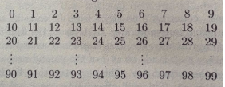  - Number line (decimals) | - Wu’s “counting array”  - Number line (decimals) | - Wu’s “counting array”  - Number line (decimals) | - Wu’s “counting array”  - Number line (decimals)
Strategies
Specifications | For Whole Numbers:  - Concept of “ones” (GK)  - 10 ones = 1 ten (GK or G1)  - 10 tens = 1 hundred (G2)  - 10 hundreds = 1 thousand  - 10 thousands = 1 ten thousand  - 10 ten thousands = 1 hundred thousand  - 10 hundred thousands = 1 million  For Decimal Numbers:  - Begin by decomposing 1 into 10 tenths to establish tenths as a place value unit  - 1 one = 10 tenths  - 1 tenth = 10 hundredths  - 1 hundredth = 10 thousandths | - Teen numbers as ten ones and some more ones (GK)  - Teen numbers as 1 ten and some ones (GK or G1)  - Two-digit numbers as tens and ones (G1)  - Three-digit numbers as hundreds, tens, and ones (G2)  - Numbers to 10,000 (G3)  - Multi-digit numbers and decimals to hundredths (G4)  - Multi-digit numbers and decimals to thousandths (G5) | - Digits 0-9 and 10 (GK)  - 11-19 and 20 (GK)  - 2-digit numbers beyond 20 (G1)  - 3-digit numbers (G1/G2)  - 4-digit numbers  - 5-digit numbers  - 6-digit numbers  - 7-digit numbers  - Decimal numbers (1, then 2, then 3 decimal places) | - Numbers to 100/120 (G1 FL and AR)  - Numbers to 1,000 (G2; TX to 1,200)  - Numbers to 10,000 (G3; TX, MO, OK, and TN to 100,000)  - Numbers to 1,000,000 (G4; TX to 1,000,000,000)  - Decimals to the hundredths (most states don’t call this out for G4)  - Decimals to the thousandths (G5)  - Use “and” to represent the decimal point in decimal numbers  - The role of commas in numbers beyond the ones period
Leaves to Include
Considerations |  | - Re: this row and the next. This row is about understanding that the position of a digit determines where the whole number lives in the counting sequence (or the location of a decimal on a number line). The next row is about being able to write that understanding in an incredibly mathematically useful canonical notation.  - Building the counting array demonstrates the genius of a place value system:  - It allows us to describe all whole numbers using only ten symbols  - As the array gets large, can introduce ellipses  - Aspire activities:  - Contrast with roman numerals  - Students can invent their own symbols and build their own arrays  - Support counting array with concrete objects  - For decimals:  - use the number line; the counting array is for whole number place value  - relate decimal fractions to decimal numbers (fraction and decimal equivalence) | - Locate and read numbers on the counting array
Required Skills/Cases | - Ones to 19 (ten ones and some more ones) (GK)  - Ones, tens (GK or G1)  - Ones, tens, hundreds (G2)  - Ones to thousands and 10,000s (G3)  - Millions to hundredths (G4)  - Billions to hundredths (G5) | - Determine the value of digits in:  - Teen numbers (GK)  - Two-digit numbers (G1)  - Three-digit numbers (G2)  - Numbers to 10,000 (G3)  - Multi-digit numbers and decimals to hundredths (G4)  - Multi-digit numbers and decimals to thousandths (G5)  - Include numbers with:  - Zeros in different places (including trailing zeros for decimals)  - Repeating digits  - Compare the value of the same digit in different places in the same number (e.g., the 3s in 1,334)  - Compare the value of the same digit across different numbers (e.g., the 3 in 312 and 3,012) | - NOTE: We will need to consider the nuances among states for our cases in this category.  - For all ranges listed below, identify (“point to the number ___”), read, and write in standard form:  - Digits 0-9 and 10 (GK)  - 11-19 and 20 (GK)  - 2-digit numbers beyond 20 (G1)  - 3-digit numbers (G1/G2)  - 4-digit numbers  - 5-digit numbers  - 6-digit numbers  - 7-digit numbers  - Decimal numbers (1, then 2, then 3 decimal places)  - Include numbers with:  - Zeros in different places (including trailing zeros for decimals)  - Repeating digits  - Decimals less than 1  - Reading the decimal point as “and” or “point” | - See specifications for number ranges by grade  - Read a number in standard form and write it word form  - Read a number in word form and write it in standard form  - Include numbers with:  - Zeros in different places (including trailing zeros for decimals)  - Repeating digits  - Decimals less than 1
Misconceptions | - From TX BB G2 M3 MO:  Students may think that 10 of a given unit should be exchanged for 10 of the next larger unit, rather than 1 of the next larger unit. (e.g., “10 tens equal 10 hundreds”). | - From TX BB G1 M4 MO: Students think the digit in a number and the value of that digit is always the same (e.g., “24 is 2 and 4”). | - From Math Catalyst, Compose, Decompose, and Represent Decimals to Thousandths: Students do not understand the role of placeholder zeros, so they may omit or misplace zeros when writing numbers in standard form. (similar in Compose, Decompose, and Represent Numbers to 100,000) | - Students represent a number in word form as a consecutive string of digits (e.g., 123 is written as one two three)  - Inserting “and” in whole number names
Existing Product Reference, if any | - EM2 GK M6 TA L1: Describe teen numbers as 10 ones and ___ ones.  - GK Strawman Lesson 2: Count out a group and represent it as tens and ones.  - EM2 G1 M3 TD L16: Identify ten as a unit.  - EM2 G1 M5 TA: Grouping Units in Tens and Ones  - EM2 G2 M5 TE: Understand Place Value Units  - EM2 FL G3 M2 TB (or MD G3 M2 TA-1)  - EM2 G4 M1 L5, L6 (multiplicative reasoning*)  - EM2 G4 M5 L1-3, 5-6  - EM2 G5 M1 L1 (multiplicative reasoning*)  - EM2 G5 M4 L1-2 (L4 multiplicative reasoning*)  *multiplicative reasoning (10 times as much) has its own row in this ladder | - EM2 GK M6 TA L1: Describe teen numbers as 10 ones and ___ ones.  - GK Strawman Lesson 2: Count out a group and represent it as tens and ones.  - EM2 G1 M3 TD L16: Identify ten as a unit.  - EM2 G1 M5 TA: Grouping Units in Tens and Ones  - EM2 G2 M5 TE: Understand Place Value Units  - EM2 FL G3 M2 TB (or MD G3 M2 TA-1)  - EM2 G4 M1 L7  - EM2 G4 M5 L36  - EM2 G5 M4 L2-3 | - EM2 FL G3 M2 TB (or MD G3 M2 TA-1)  - EM2 G4 M1 L8  - EM2 G4 M5 L1-4, 5-7  - EM2 G5 M4 L3 | - EM2 G2 M1 L27 Learn 1  - EM2 FL G3 M2 L10 Learn 1  - EM2 G4 M1 L8  - EM2 G5 M4 L2 Learn 2  Math Catalyst, Place Value:  - Compose, Decompose, and Represent Numbers to 1,000, Objective 4  - Compose, Decompose, and Represent Numbers to 100,000, Objective 4  - Compose, Decompose, and Represent Multi-Digit Numbers, Objective 4  - Compose, Decompose, and Represent Decimals to Hundredths, Objective 4  - Compose, Decompose, and Represent Decimals to Thousandths, Objective 4
Grade (or Leaf) | K-5 | K-5 | K-5 | 2-5 (G1 for FL and AR)
Notes related to Standards, Grade, or Leaf | K-2  K.NBT.A.1  1.NBT.B.2  1.NBT.B.2.a  1.NBT.B.2.b  1.NBT.B.2.c  2.NBT.A.1  2.NBT.A.1.a  2.NBT.A.1.b  MD.K.NOS.C.9.b  3-5  AR.3.NPV.2  MN.3.3.5.2  NY.3.NBT.4a  OK.3.N.1.2  VA.3.NS.1.b | K-2  K.NBT.A.1  1.NBT.B.2  1.NBT.B.2.b  1.NBT.B.2.c  2.NBT.A.1  2.NBT.A.1.b  MD.K.NOS.C.9.b  3-5  TX.4.2B  TX.5.2A  AR.3.NPV.2  NY.3.NBT.4a  VA.3.NS.1.b | K-2  1.NBT.A.1  2.NBT.A.3  FL.1.NSO.1.2  FL.2.NSO.1.1  TX.K.2B  AR.1.NPV.4  3-5  4.NBT.A.2  4.NF.C.6  5.NBT.A.3 and 3a  FL.3.NSO.1.1  FL.4.NSO.1.2  FL.4.FR.1.2  FL.5.NSO.1.2  TX.4.2B  TX.5.2A  AR.3.NPV.3  GA.3.NR.1.1  IN.3.NS.1  KS.4.NBT.2  MD.3.NOS.A.1.a  MO.3.NBT.A.2  MO.5.NBT.A.1  NE.3.N.1.a  NE.4.N.1.a  NE.5.N.1.a  NY.3.NBT.4b  ND.3.NO.CC.1  OK.3.N.1.2  SC.3.NR.1.1  SC.4.NR.1.1  TN.3.NBT.A.4  VA.3.NS.1.a | K-2  2.NBT.A.3  FL.1.NSO.1.2  FL.2.NSO.1.1  TX.2.2B  AR.1.NPV.4  3-5  4.NBT.A.2  5.NBT.A.3a  FL.3.NSO.1.1  FL.4.NSO.1.2  FL.5.NSO.1.2  AR.3.NPV.3  IN.3.NS.1  IN.4.NS.4  KS.4.NBT.2  MD.3.NOS.A.1.a  MO.3.NBT.A.2  MO.5.NBT.A.1  NY.3.NBT.4b  ND.3.NO.CC.1  OK.3.N.1.1  OK.3.N.1.2  SC.3.NR.1.1  SC.4.NR.1.1  TN.3.NBT.A.4  VA.3.NS.1.a  VA.4.NS.1.a  VA.4.NS.1.b
Notes for Intervention, Extension, or Optional Activities | Intervention  - Math Catalyst, Compose, Decompose, and Represent Numbers to 100,000, Concept Mini Lesson 1  - Math Catalyst, Compose, Decompose, and Represent Multi-Digit Numbers, Concept Mini Lesson 1  - Math Catalyst, Compose, Decompose, and Represent Decimals to Hundredths, Concept Mini Lesson 1  - Math Catalyst, Compose, Decompose, and Represent Decimals to Thousandths, Concept Mini Lesson 1  Extension  - Math Catalyst, Compose, Decompose, and Represent Decimals to Hundredths, Application, Solve a Problem  - Math Catalyst, Compose, Decompose, and Represent Decimals to Thousandths, Application, Solve a Problem | Intervention  - From TX BB G1 M4 MO: Use place value cards to represent a number. Pull the cards apart to show the value of each digit separately. Push them back together to unify the values as one number.  - Math Catalyst, Compose, Decompose, and Represent Numbers to 100,000, Concept Mini Lessons 1, 2, and 4  - Math Catalyst, Compose, Decompose, and Represent Multi-Digit Numbers, Concept Mini Lesson 2  - Math Catalyst, Compose, Decompose, and Represent Decimals to Hundredths, Concept Mini Lesson 2  - Math Catalyst, Compose, Decompose, and Represent Decimals to Thousandths, Concept Mini Lesson 2  Extension  - EM2 G4 M1 Math Past  - EM2 G4 M5 Math Past  - Math Catalyst, Compose, Decompose, and Represent Numbers to 100,000, Application Solve a Task  - Math Catalyst, Compose, Decompose, and Represent Multi-Digit Numbers, Application Solve a Task  - Math Catalyst, Compose, Decompose, and Represent Decimals to Hundredths, Application, Solve a Task  - Math Catalyst, Compose, Decompose, and Represent Decimals to Thousandths, Application, Solve a Task | Intervention  - Math Catalyst, Compose, Decompose, and Represent Numbers to 100,000, Concept Mini Lessons 2 and 4  - Math Catalyst, Compose, Decompose, and Represent Multi-Digit Numbers, Concept Mini Lesson 4  - Math Catalyst, Compose, Decompose, and Represent Decimals to Hundredths, Concept Mini Lesson 4  - Math Catalyst, Compose, Decompose, and Represent Decimals to Thousandths, Concept Mini Lesson 4 | Extension: Transfer across multiple forms
Additional Notes | Additional Notes  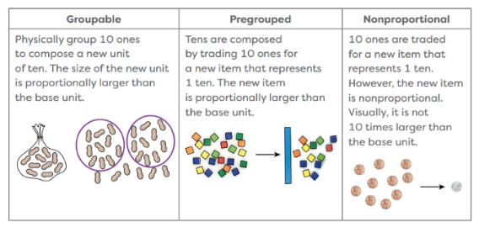  - Incorporate use of concrete materials/bundling to build conceptual understanding when introducing new PV units  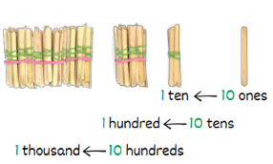  GK: Part of an instructional period  G1: Likely 3 instructional periods  G2: Likely 2 instructional periods  G3: Likely 1 instructional period  G4: Likely 2 instructional periods (1 whole numbers, 1 decimals)  G5: Likely 2 instructional periods (1 whole numbers, 1 decimals) | GK: Likely 5 instructional periods, with additional practice time needed  G1: Likely 3 instructional periods  G2: Likely 2 instructional periods  G3: Likely 1 instructional period  G4: Likely 2 instructional periods (1 whole numbers, 1 decimals)  G5: Likely 2 instructional periods (1 whole numbers, 1 decimals) | GK: Identify numerals: Likely 1 instructional period (new), Writing numerals 1 instructional period (new) -Heavy emphasis on practice and developmental abilities for writing  G1: Likely 1 instructional period, combined with prior columns  G2: Likely 1 instructional period  G3: Likely part of an instructional period  G4: Likely part of other instructional periods (whole numbers, decimals)  G5: Likely part of other instructional periods (whole numbers, decimals) | G1 (for FL and AR): Likely 1 instructional period  G2: Likely 1 instructional period  G3: Likely part of 1 instructional period  G4: Likely part of 2 instructional periods (1 for whole numbers and one for decimals)  G5: Likely part of 1 instructional period

Concept/Skill: Read and write numbers in expanded form.
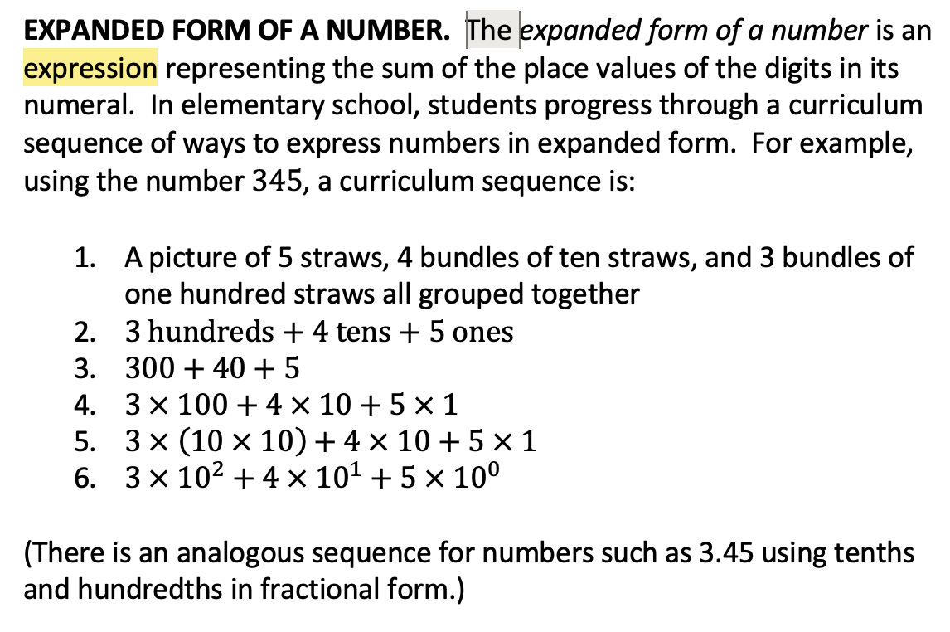 Danielle sent this in Slack 5/18, sticking it here so we have it handy

Goal | Represent/understand numbers as the sum of the value of each digit
Student-Facing Example | 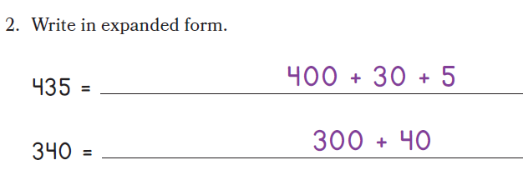
Knowledge Graph Node | Read and write numbers in expanded form by using addition. | Read and write numbers in expanded form by using multiplication and addition. | Read and write whole numbers in expanded form by using multiplication by powers of 10 and addition.
Terminology | Expanded Form: an expression representing the sum of the place values of the digits in a number
Mathematical Models | - Wu’s “counting array”  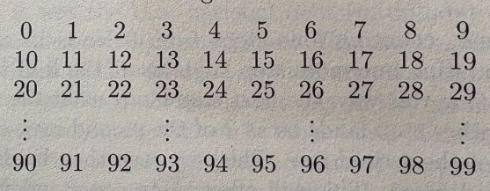  - Equations  - Number line (decimals) | - Equations  - Number line (decimals) | - Equations
Strategies
Specifications | - Convention of writing starting with the largest PV units  - Numbers to 100 (FL G1; TX to 120)  - Numbers to 1,000 (G2; TX to 1,200)  - Numbers to 10,000 (G3; TX, MO, OK, and TN to 100,000)  - Numbers to 1,000,000 (G4; TX to 1,000,000,000)  - Decimals to hundredths (G4)  - Decimals to thousandths (G5) | - Convention of writing the equation starting with the largest PV units  - Numbers to 100,000 (TX G3)  - Numbers to 1,000,000 (G4)  - Numbers to 1,000,000,000 and decimals to hundredths (TX G4)  - Decimals to thousandths (G5)  - Use parentheses to group each place value term | - Convention of writing the equation starting with the largest PV units  - Multi-digit whole numbers  - Use parentheses to group each place value term  - ${10}^{0}=1$ must be explicitly addressed
Leaves to Include
Considerations | - Notes on different forms  - can use unit form first (37 is 3 tens 7 ones)  - transition to expanded form ($37 = 30 + 7$) as students get addition (+) tools  - Connect counting array location to digits: 37 is row 3, column 7 ⇒ 37 = $3×10+7$ (up to 99)  - Record 0-digits explicitly (e.g., $304=3×100+0×10+4$)  - For decimals, use the number line not the counting array as a visual model, if you need one.  Re: this row and the previous. The previous row is about understanding that the position of a digit determines where the whole number lives in the counting sequence (or the location of a decimal on a number line). The next row is about being able to write that understanding in an incredibly mathematically useful canonical notation. | - Notes on different forms  - transition to expanded form with multiplication and exponents ($307 = 3×{10}^{2}+0×{10}^{1} + 7×{10}^{0}$) after students get ${10}^{n}$ notation | - Notes on different forms  - transition to expanded form with multiplication and exponents ($307 = 3×{10}^{2}+0×{10}^{1} + 7×{10}^{0}$) after students get ${10}^{n}$ notation
Required Skills/Cases | - See Specifications for number ranges by grade  - Numbers with no 0s  - Numbers with a 0 in one place  - Numbers with 0s in multiple places  - Given standard form, write expanded form  - Given expanded form, write standard form  - Decimals as fraction notation  - Decimals as decimal notation | - See Specifications for number ranges by grade  - Numbers with no 0s  - Numbers with a 0 in one place  - Numbers with 0s in multiple places  - Given standard form, write expanded form  - Given expanded form, write standard form  - Given expanded form with addition, rewrite as expanded form with multiplication  - Decimals as fraction notation  - Decimals as decimal notation | - Numbers with no 0s  - Numbers with a 0 in one place  - Numbers with 0s in multiple places  - The ones place as $×{10}^{0}$  - Given standard form, write expanded form  - Given expanded form, write standard form  - Given expanded form with multiplication, rewrite as expanded form with powers of 10
Misconceptions | - When given expanded form, not recording 0 for a place value unit and collapsing remaining digits (e.g., interpreting 300 + 4 as 34 instead of 304)  - Confusing the digit with the value of the digit (e.g., writing 123 as 1 + 2 + 3)  - For decimals: ignoring decimal place value (e.g., writing 3.47 as 3 + 4 + 7 or 3 + 40 + 7) | - Treating the ones place as not needing multiplication (e.g., $345=3×100+4×10+5$) | - Confusing the exponent with the digit (e.g., writing 400 as $4×{10}^{4}$)  - Confusing the exponent with the digit’s position from the right (e.g., recording a digit in the hundreds place as ${10}^{3}$ because the hundreds place is the third place)  - Treating ${10}^{0}$ as 0 or 10
Existing Product Reference, if any | G2 M1 L26  G4 M1 L7, L8  G4 M4 L4 (decimals)  G4 M4 L8 (decimals)  G5 M1 L1  G5 M4 L3 (decimals)  Math Catalyst, Place Value:  - Compose, Decompose, and Represent Numbers to 120; Objectives 2 and 4  - Compose, Decompose, and Represent Numbers to 1,000; Objective 3  - Compose, Decompose, and Represent Numbers to 100,000; Objective 3  - Compose, Decompose, and Represent Decimals to Thousandths; Objective 3  FL G1 M5 L3 and L5 | G4 M1 L7  G5 M1 L7 Launch  G5 M4 L3 (decimals)  Math Catalyst, Place Value:  - Compose, Decompose, and Represent Numbers to 100,000; Objective 3  - Compose, Decompose, and Represent Multi-Digit Numbers; Objective 3  - Compose, Decompose, and Represent Decimals to Hundredths; Objective 3  - Compose, Decompose, and Represent Decimals to Thousandths; Objective 3 | Powers of 10 are introduced in G5 M1 L3, but not used to represent numbers in expanded form
Grade (or Leaf) | 2, 3, 4, 5 (G1 for FL) | 4, 5 (G3 for TX and AR) | 5
Notes related to Standards, Grade, or Leaf | 2.NBT.A.3  4.NBT.A.2  5.NBT.A.3.a  FL.1.NSO.1.2  FL.2.NSO.1.1  FL.3.NSO.1.1  FL.4.NSO.1.2  FL.5.NSO.1.2  TX.1.2C  TX.2.2B  TX.3.2A  AR.3.NPV.3  GA.3.NR.1.1  IN.3.NS.1  KS.4.NBT.2  MD.3.NOS.A.1.a  MO.3.NBT.A.2  MO.5.NBT.A.1  NE.3.N.1.a  NE.4.N.1.a  NE.5.N.1.a  NY.3.NBT.4b  ND.3.NO.CC.1  OK.3.N.1.2  SC.3.NR.1.1 (to 999,999)  SC.4.NR.1.1 (to 999,999,999)  TN.3.NBT.A.4  VA.3.NS.1.a (six digit numbers) | 4.NBT.A.2  5.NBT.A.3.a  FL.4.NSO.1.2  FL.5.NSO.1.2  TX.3.2A  TX.4.2B  TX.5.2A  AR.3.NPV.3  KS.4.NBT.2  MO.5.NBT.A.1  NE.4.N.1.a  NE.5.N.1.a  SC.4.NR.1.1 (to 999,999,999) | 5.NBT.A.2
Notes for Intervention, Extension, or Optional Activities | Intervention:  - Start with unit form, then transition to addition equations  - If not used in core lessons, use PV disks and PV charts to support expanded form  Extension: Explore why expanded form is useful, connect to addition and subtraction algorithms  Optional:  - Extend to other number ranges to meet various state standards  - Show equivalency with PV units written in a different order (e.g., 345 = 300 + 40 + 5 = 40 + 5 + 300) | Intervention: write numbers in expanded form using addition as a scaffold before transitioning to expanded form with multiplication  Optional:  - Show equivalency with PV units written in a different order | Intervention: connect powers of 10 to repeated multiplication before introducing exponential notation (e.g., $100=10 ×10={10}^{2}$)  Optional:  - Show equivalency with PV units written in a different order  Extension  - Writing numbers in different bases. Binary, hexadecimal, base 20 (math past connection), etc.
Additional Notes | G2: Likely 1 instructional period  G3: Likely part of 1 instructional period  G4: Likely part of 2 instructional periods (one for whole numbers and one for decimals)  G5: Likely part of 2 instructional periods (one for whole numbers and one for decimals) | G4: Likely part of 1 instructional period  G5: Likely part of 2 instructional periods (one for whole numbers and one for decimals) | G5: Likely part of an instructional period

Concept/Skill: Represent, compose, and decompose numbers.

Goal | Understand the structure of the base ten place value system as based in repeated bundling in groups of 10
Student-Facing Example | 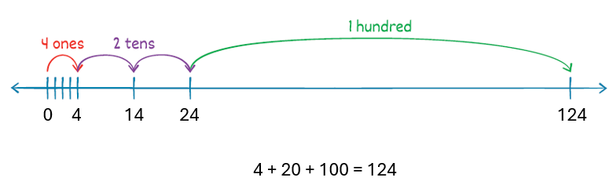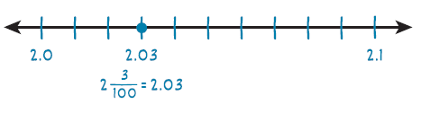
Knowledge Graph Node | Represent, compose, and decompose whole numbers flexibly by using place value units. | Represent, compose, and decompose decimal numbers flexibly by using place value units.
Terminology
Mathematical Models | - Wu’s “counting array”  - Expanded form equations  - Number line | - Expanded form equations  - Number line
Strategies
Specifications | - Teen numbers (GK)  - Numbers to 100 (G1; TX to 120)  - Numbers to 1,000 (G2; TX to 1,200)  - Numbers to 10,000 (G3; TX, MO, OK, and TN to 100,000)  - Numbers to 1,000,000 (G4; TX to 1,000,000,000)  - Numbers beyond 1,000,000 (G5)  - Unit form | - Decimals to the hundredths (G4)  - Decimals to the thousandths (G5)  - Unit form
Leaves to Include
Considerations | - Use counting array edge crossings to justify renaming (e.g., 19 ones crosses to next row ⇒ 1 ten 9 ones) to start, later lean on associative/commutative/distributive properties as students use more sophisticated “expanded forms”  - Use the most advanced “expanded” form kids have access to: unit form; expanded with multiplication (preferred); additive expanded etc.  - Place value charts are useful pedagogical tools that can be used to organize work and to scaffold understanding, but they are not “the math”. Favor equations and the number line – these are “the math”. When using place value charts, always connect to equations/expressions.  - Understand the unit associated with each place is 10 of the unit associated with the place to its right  - Counting Array becomes cumbersome with larger numbers and doesn’t extend to making sense of place values beyond tens and ones (should be a mental image)  - Represent numbers in different forms  while “expanded form” is about a canonical decomposition of a number according to place value, this row broadens our scope outside of the canonical representation of expanded form and lets us represent numbers in various ways depending on what is more useful for the task at hand. | - For decimals:  - use the number line  - relate decimal fractions to decimal numbers (fraction and decimal equivalence)
Required Skills/Cases | - See specifications for number ranges by grade  - Compose a number given its canonical place value parts (e.g., given 3 tens 7 ones, identify 37)  - Decompose a number into its canonical place value parts (e.g., given 37, identify 3 tens 7 ones)  - Non-canonical composition (e.g., 2 tens 17 ones = 37)  - Non-canonical decomposition (e.g., 37 = 2 tens 17 ones)  - Given standard form, create a decomposition  - Given a decomposition, write standard form  - Given a decomposition, write a different decomposition  - Write up to 4 different decompositions to represent the same number  - Numbers with a 0 in one place (e.g., 304 = 3 hundreds 0 tens 4 ones)  - Numbers with 0s in multiple places  - Multiples of 10, 100, 1,000 (e.g., 70 = 7 tens)  - Represent a number as a multiple of a unit (e.g., 37 = 37 ones)  - Represent using:  - Objects (groupable, pre-grouped, proportional, and nonproportional)  - Drawings (proportional and nonproportional)  - Counting array  - Number line  - Equations (most advanced expanded form available) | - See specifications for number ranges by grade  - Compose a decimal number given its canonical place value parts (e.g., given 3 ones 7 tenths, identify 3.7)  - Decompose a decimal number into its canonical place value parts (e.g., given 3.7, identify 3 ones 7 tenths)  - Non-canonical composition (e.g., 2 ones 17 tenths = 3.7)  - Non-canonical decomposition (e.g., 3.7 = 2 ones 17 tenths)  - Given standard form, create a decomposition  - Given a decomposition, write standard form  - Given a decomposition, write a different decomposition  - Write up to 4 different decompositions to represent the same number  - Numbers with a 0 in one place (e.g., 3.04 = 3 ones 0 tenths 4 hundredths)  - Numbers with 0s in multiple places  - Multiples of 0.1, 0.01, and 0.001 with no whole number part (e.g., 0.7 = 7 tenths)  - Represent a decimal number as a multiple of a unit (e.g., 2.3 = 23 tenths and 4.50 = 450 hundredths)  - Relate decimal fractions to decimal numbers (e.g., $\frac{27}{100}=0.27$)  - Represent using:  - Objects (TX requires money for decimal representations)  - Drawings  - Number line  - Equations (most advanced expanded form available)
Misconceptions | - When composing a number, ignoring the place value of each part and just writing the digits (e.g., given 3 tens 14 ones, writing 314 instead of 44)  - Misconceptions from Math Catalyst:  - Students decompose a teen number into 1 and some more ones. For example, students may decompose 16 as 1 and 6.  - When representing numbers, students might not understand how to use the digit 0 to represent 0 of a place value unit. Students might record 6 hundreds 0 tens 4 ones in standard form as 64.  - Students may omit or misplace zeros when writing numbers in standard form because they do not understand the role of placeholder zeros. | - Confusing the digit in a place with naming a number by that place value unit (e.g., thinking that 2.3 represented as tenths is 3 tenths, instead of 23 tenths)  - Treating decimal fractions and decimal numbers as different numbers
Existing Product Reference, if any | EM2:  - GK M6 L1-L12  - G1 M3 L15 and 16, G1 M5 L2-L5  - G2 M1 L20, L23, L24, L25, L27, L28, L30-L34  - G3 M2 L1 and L4 (place value in the context of metric measurement)  - G4 M1 L5, L7, L8, L10  Math Catalyst, Place Value:  - Compose, Decompose, and Represent Teen Numbers  - Compose, Decompose, and Represent Numbers to 120  - Compose, Decompose, and Represent Numbers to 1,000  - Compose, Decompose, and Represent Numbers to 100,000  - Compose, Decompose, and Represent Multi-Digit Numbers | EM2:  - G4 M5 L1-L8  - G5 M4 L1, L2, L3  Math Catalyst, Place Value:  - Compose, Decompose, and Represent Decimal to Hundredths  - Compose, Decompose, and Represent Decimals to Thousandths
Grade (or Leaf) | K, 1, 2, 3, 4 | 4, 5
Notes related to Standards, Grade, or Leaf | K.NBT.A.1  1.NBT.B.2-2.c  2.NBT.A.1-1.b  2.NBT.A.3  4.NBT.A.2  FL.K.NSO.2.2  FL.1.NSO.1.3  FL.2.NSO.1.2  FL.3.NSO.1.2  FL.4.NSO.1.2  TX.K.2B, TX.K.2I  TX.1.2B, TX.1.2C  TX.2.2A, TX.2.2B, TX.2.9C  TX.3.2A  TX.4.2B  MD.K.NOS.C.9.b  MD.1.NOS.B.3.c  WY.2.NBT.1C  Most of the standards below are gaps that are probably addressed in other nodes but have implications here:  - (states that have PV standards in G3) AR.3.NPV.3, GA.3.NR.1.1, IN.3.NS.1, MD.3.NOS.A.1. and 1.b, NE.3.N.1.a, MO.3.NBT.A.2, NY.3.NBT.4b, ND.3.NO.CC.1, OK.3.N.1.1, SC.3.NR.1.1, SC.3.NR.1.2, VA.3.NS.1.a and 1.c  - (K-1 number lines) MD.1.NOS.B.4  - (number range is different from CCSS) AR.1.NPV.4, SC.4.NR.1.1, TN.3.NBT.A.4 | 4.NF.C.6  5.NBT.A.3.a  FL.4.FR.1.2  FL.5.NSO.1.3  TX.4.2E  TX.5.2A  MO.5.NBT.A.1  NE.4.N.1.a  NE.5.N.1.a  OK.5.N.1.2
Notes for Intervention, Extension, or Optional Activities | Intervention: If not used in core lessons, use place value charts, place value cards, and place value disks (use bundles in earlier grades) to compose and decompose numbers  Optional: use money as a representation to support PV understanding | Intervention: If not used in core lessons, use place value charts, place value cards, and place value disks to compose and decompose numbers  Optional: use money as a representation to support PV understanding
Additional Notes | GK: Likely 3 instructional periods  G1: Likely 2 instructional periods  G2: Likely 2 instructional periods  G3: Likely 1 instructional period  G4: Likely 1 instructional period  NOTE: Additional practice opportunities should be embedded throughout the module and across the year, particularly as students encounter rounding, addition, subtraction, multiplication, or division. | G4: Likely 2 instructional periods (might be partial, one for tenths and one for hundredths)  G5: Likely 1 instructional period  NOTE: Additional practice opportunities should be embedded throughout the module and across the year, particularly as students encounter rounding, addition, subtraction, multiplication, or division.

Concept/Skill: Compare and order numbers by using place value.

Goals | - Identify relationships between quantities (less than, greater than, or equal to)  - Compare multiple quantities to sequence them
Student-Facing Example | 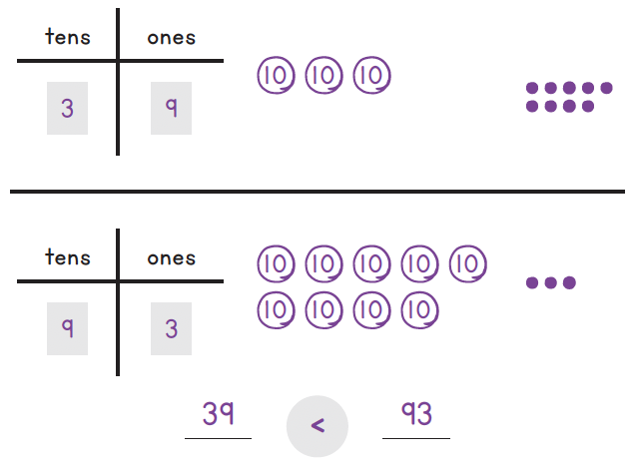
Knowledge Graph Node | Compare whole numbers by using place value.  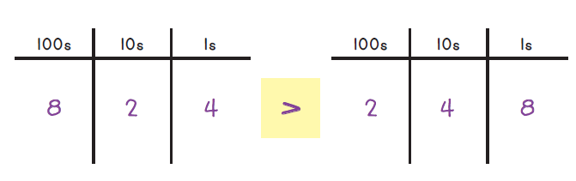 | Order whole numbers by using place value. | Compare decimal numbers by using place value.  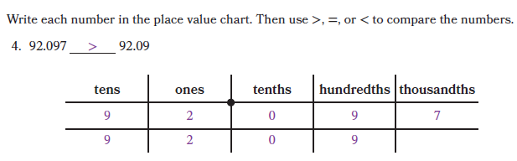 | Order decimal numbers by using place value.
Terminology
Mathematical Models | - Wu’s “counting array”  - Number line  - Expanded form | - Wu’s “counting array”  - Number line  - Expanded form | - Expanded form | - Expanded form
Strategies
Specifications | - Some place value charts ok, but don’t rely heavily on place value charts (like EM2/Catalyst), lean on expanded form  - Use symbols: >, <, =  - Compare two-digit numbers (G1)  - Compare three-digit numbers (G2)  - Compare numbers to 10,000 (G3)  - Compare numbers to 1,000,000 (G4) | - Some place value charts ok, but don’t rely heavily on place value charts (like EM2/Catalyst), lean on expanded form  - Order two-digit numbers (G1)  - Order three-digit numbers (G2)  - Order numbers to 10,000 (G3)  - Order numbers to 1,000,000 (G4)  - Sets of 3 to about 5 numbers | - Some place value charts ok, but don’t rely heavily on place value charts (like EM2/Catalyst), lean on expanded form  - Use symbols: >, <, =  - Compare decimals to the hundredths (G4)  - Compare decimals to the thousandths (G5) | - Some place value charts ok, but don’t rely heavily on place value charts (like EM2/Catalyst), lean on expanded form  - Order decimals to the hundredths (G4)  - Order decimals to the thousandths (G5)  - Sets of 3 to about 5 numbers
Leaves to Include
Considerations | - Compare the digits in the highest place first; if equal, move to the next highest place  - Justification: Compare the highest place where the digits differ. A difference of 1 in the tens place is worth 10 ones, which is greater than the largest possible difference in the ones place, 9. Similarly, a difference of 1 in the hundreds place is worth 100, greater than the largest possible difference from tens and ones combined, 99.  - (Teacher-facing) Expanded form reasoning: $48=4×10+8$ and $52=5×10+2$; since $5×10>4×10$, $52>48$  - Within 20 use bundles; then two-digit numbers; then three-digit with base ten blocks/drawings
Required Skills/Cases | - Compare numbers with different numbers of digits (number choices match grade-level specifications)  - Compare numbers with the same number of digits:  - Different digits in the greatest place value  - Same digit in the greatest place value  - Same digit in multiple places  - Include numbers with zeros in one or more places (e.g., 304 vs 340) | - Least to greatest  - Greatest to least  - Sets of numbers with different number of digits  - Sets of numbers with the same number of digits:  - Different digits in the greatest place value  - Same digit in the greatest place value  - Same digit in multiple places  - Sets of numbers with zeros in one or more places | - Compare decimals with the same whole number parts  - Compare decimals with different whole number parts  - Compare decimals with a different number of decimal places  - Compare decimals with the same number of decimal places:  - Different digits in the greatest place value  - Same digit in the greatest place value  - Same digit in multiple places  - Include numbers with zeros in one or more places (e.g., 3.04 vs 3.40) | - Least to greatest  - Greatest to least  - Sets of decimals with different whole number parts  - Sets of decimals with the same whole number part  - Sets of decimals with a different number of decimal places  - Sets of decimals with the same number of decimal places:  - Different digits in the greatest place value  - Same digit in the greatest place value  - Same digit in multiple places  - Sets of numbers with zeros in one or more places
Misconceptions | - Comparing by only considering the digit in the greatest place value unit (e.g., thinking 903 is greater than 1,234 because 9 is greater than 1) | - Ordering by looking at pairs of numbers instead of across the entire set of numbers | - Comparing based only on the number of digits (e.g., thinking 1.23 is greater than 10 because it has more digits)  - Comparing based on the number of digits after the decimal point (e.g., 1.23 is greater than 1.3 because it has more digits after the decimal point) | - Ordering by only considering the whole number part or the decimal part of the numbers
Existing Product Reference, if any | EM2 G1 M5 L7, L8  EM2 G2 M1 L35, L36, L37  EM2 G4 M1 L9 Learns 1 and 2  Math Catalyt, Place Value:  - Compare and Order Numbers to 120 (Objectives 1 and 2)  - Compare and Order Numbers to 1,000 (Objectives 1 and 2)  - Compare and Order Numbers to 100,000 (Objectives 1 and 2) | EM2 G2 M1 L38 Learn 1  EM2 G4 M1 L9 Learn 3  Math Catalyt, Place Value:  - Compare and Order Numbers to 120 (Objective 3)  - Compare and Order Numbers to 1,000 (Objectives 3 and 4)  - Compare and Order Numbers to 100,000 (Objective 3) | EM2 G4 M5 L10 Learn 2  EM2 G5 M4 Lesson 6 Learns 2 and 3  Math Catalyt, Place Value:  - Compare and Order Decimals to Thousandths (Objective 2) | EM2 G4 M5 L11 Learn 2  EM2 G5 M4 Lesson 6 Learn 3  Math Catalyt, Place Value:  - Compare and Order Decimals to Thousandths (Objective 4)
Grade (or Leaf) | 1, 2, 3, 4 | 1, 2, 3, 4 | 4, 5 | 4, 5
Notes related to Standards, Grade, or Leaf | K.CC.C.7  1.NBT.B.3  2.NBT.A.4  4.NBT.A.2  FL.K.NSO.1.4, FL.K.NSO.2.3  FL.1.NSO.1.4  FL.2.NSO.1.3  FL.3.NSO.1.3  FL.4.NSO.1.3, FL.4.NSO.1.5  FL.5.NSO.1.4  TX.K.2G, TX.K.2H  TX.1.2E-1.2G  TX.2.2D  TX.3.2D  TX.4.2C  AL.K.FC.7  AK.1.CC.5  AR.2.NPV.5  AR.3.NPV.4  GA.3.NR.1.2  KS.PK.M.CC.p4.8  KS.1.NBT.3, KS.2.NBT.4, KS.4.NBT.2 (≠)  MD.K.NOS.C.10  MD.1.NOS.B.5  MD.2.NOS.A.4  MD.3.NOS.A.1.d  MN.2.3.6.1  MN.3.3.5.3  MN.4.3.5.2  NE.3.N.1.b  ND.3.NO.NBT.1  OK.3.N.1.4  PA.M03.A-T.1.1.4 (ordering)  SC.3.NR.1.3  VA.K.NS.2.g  VA.1.NS.2.f (ordering)  VA.3.NS.2.a and 2.b  VA.4.NS.2.a | K.CC.C.7  1.NBT.B.3  2.NBT.A.4  4.NBT.A.2  FL.K.NSO.1.4, FL.K.NSO.2.3  FL.1.NSO.1.4  FL.2.NSO.1.3  FL.3.NSO.1.3  FL.4.NSO.1.3, FL.4.NSO.1.5  FL.5.NSO.1.4  TX.K.2G, TX.K.2H  TX.1.2E-1.2G  TX.2.2D  TX.3.2D  TX.4.2C  AL.K.FC.7  AK.1.CC.5  AR.2.NPV.5  AR.3.NPV.4  GA.3.NR.1.2  KS.PK.M.CC.p4.8  KS.1.NBT.3, KS.2.NBT.4, KS.4.NBT.2 (≠)  MD.K.NOS.C.10  MD.1.NOS.B.5  MD.2.NOS.A.4  MD.3.NOS.A.1.d  MN.2.3.6.1  MN.3.3.5.3  MN.4.3.5.2  NE.3.N.1.b  ND.3.NO.NBT.1  OK.3.N.1.4  PA.M03.A-T.1.1.4 (ordering)  SC.3.NR.1.3  VA.K.NS.2.g  VA.1.NS.2.f (ordering)  VA.3.NS.2.a and 2.b  VA.4.NS.2.a | 4.NF.C.7 (decimals to hundredths)  5.NBT.A.3 and 3.b (decimals to thousandths)  TX.4.2F  TX.5.2B  KS.4.NF.7  KS.5.NBT.3b  MN.4.3.5.15  MN.5.3.5.9  MO.5.NBT.A.2  OK.5.N.1.3  VA.5.NS.1.d | 4.NF.C.7 (decimals to hundredths)  5.NBT.A.3 and 3.b (decimals to thousandths)  TX.4.2F  TX.5.2B  KS.4.NF.7  KS.5.NBT.3b  MN.4.3.5.15  MN.5.3.5.9  MO.5.NBT.A.2  OK.5.N.1.3  VA.5.NS.1.d
Notes for Intervention, Extension, or Optional Activities | - Intervention: Use place value disks or other manipulatives to compare numbers (if not used in the core lesson)  - Extension: Compare numbers in different forms (EM2 G2 M1 L38)  - Optional: ≠ (to meet some state standards) | - Intervention: Use place value disks or other manipulatives to order numbers (if not used in the core lesson); use index cards to support students in physically arranging the numbers  - Extension: Given a set of numbers with one number missing, determine what number(s) could fill the missing position to make a given ordering true | - Intervention: Compare by renaming as a fraction and using an area model (EM2 G4 M5 L10: Learn 1)  - Extension: generate decimals that fit comparison constraints (e.g., a decimal that is greater than 0.3 and less than 0.4)  - Optional: ≠ (to meet some state standards) | - Intervention: Use place value disks or other manipulatives to order decimals (if not used in the core lesson); use index cards to support students in physically arranging the decimals  - Extension: Mystery number based on clues (e.g., I have a 2 in the hundredths place. I am less than 3.15 but greater than 3.10.)
Additional Notes | G1: Likely 3 instructional periods  G2: Likely 2 instructional periods (heavy fluency practice)  G3: Likely part of 1 instructional period  G4: Likely part of 1 instructional period | G1: 1 instructional period  G2: 1 instructional period  G3: Likely part of 1 instructional period  G4: Likely part of 1 instructional period | G4: Likely part of 1 instructional period  G5: Likely part of 1 instructional period | G4: Likely part of 1 instructional period  G5: Likely part of 1 instructional period

Concept/Skill: Round numbers by using place value.

Goal | Determine which multiple of 10, multiple of 100, etc. a number is closer to
Student-Facing Example | 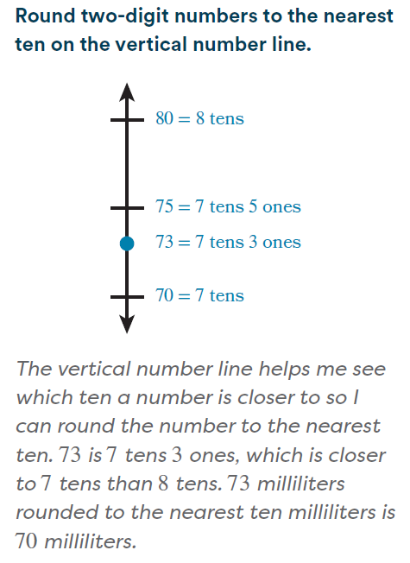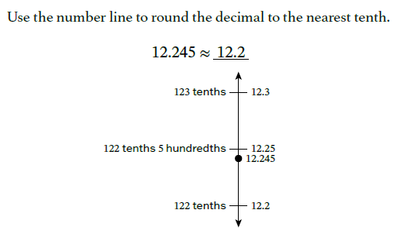
Knowledge Graph Node | Round numbers by using place value.
Terminology
Mathematical Models | - Wu’s “counting array”  - Number line
Strategies
Specifications | - Closer to, halfway, and about thinking and language  - 60 and 70 do not change when rounded to the nearest ten because they are already tens  - Rounding to a different place does not necessary yield a different result (97 rounded to the nearest 10 is 100 and rounded to the nearest 100 is also 100)  - $≈$ symbol  - Use number line, also use place value understanding/reasoning without the visual
Leaves to Include
Considerations | - Definition: nearest on the number line/row segment of the counting array  - Numbers that represent midpoints (ending in 5) are addressed explicitly, and the chosen rounding rule is clearly identified as a convention  - Look carefully at how far the rounded number is from the exact number. This distance, measured in ones or in the place value rounded to, shows how much error there is, or how “off” the rounded number might be  - There are multiple ways to round (round up, round down, round to nearest). Usually rounding refers to nearest. Consider showing real world examples when we round differently. Ex: We always round down to the nearest year value when stating our age. Rounding up is useful when budgeting.
Required Skills/Cases | Whole numbers  - Up to 100, round to nearest 10 (core G3, leaf FL, VA G2)  - Up to 1,000, round to nearest 10 (G3)  - Up to 1,000,000, round to nearest 10 (G4)  - Up to 1,000, round to nearest 100 (G3)  - Up to 10,000, round to nearest 100 (G3)  - Up to 100,000 round to nearest 10, 100, or 1,000 (TX G3 leaf)  - Up to 10,000, round to nearest 1,000 (G4)  - Up to 100,000, round to nearest 1,000 (G4)  - Up to 1,000,000, round to nearest 1,000 (G4)  - Up to 1,000,000 round to nearest 10,000 (G4)  - Up to 1,000,000, round to nearest 100,000 (G4)  - Determine what place or method (up/down/nearest) makes sense for context (G3, G4)  - Numbers already at the target place value (e.g., 60 rounded to nearest ten) (G3, G4)  - Halfway cases (G3, G4)  - Rounding where two different place values yield the same result (e.g., 98 rounded to the nearest 10 and 100) (G3, G4)  Decimals  - Numbers with 7 or fewer digits to left of decimal and up to 3 digits to right of decimal, round to any place (focus on numbers with 4 or fewer digits to left of decimal and rounding to nearest hundredth, tenth, or whole) (G5, MO needs 10 digits to left)  - Money amounts to the nearest dollar  - Determine what place or method (up/down/nearest) makes sense for context (G5)  - Halfway cases (G5)  - Rounding where two different place values yield the same result (e.g., 0.98 rounded to the nearest whole and tenth) (G5)
Misconceptions | Students think the digit in the target place is the total number of that place value instead of also considering the larger places. For example, when rounding 1.27 to the nearest tenth, students say the number is between 2 tenths and 3 tenths. (Math Catalyst, Round to the Nearest Ten and Hundred and Math Catalyst, Round Decimals to Tenths or Hundredths)
Existing Product Reference, if any | - EM2 G3 M2 L9–L11  - EM2 G4 M1 L12–L15  - EM2 G5 M4 L7–L8  - Math Catalyst, Place Value, Round to the Nearest Ten and Hundred, Concept Mini Lessons 1–3  - Math Catalyst, Place Value, Round to Tenths or Hundredths, Concept Mini Lessons 1–4
Grade (or Leaf) | 3, 4, 5  Leaves put some content at different grade levels
Notes related to Standards, Grade, or Leaf | 3.NBT.A.1  4.NBT.A.3  5.NBT.A.4  FL.2.NSO.1.4  FL.3.NSO.1.4  FL.4.NSO.1.4  FL.5.NSO.1.5  TX.3.2C  TX.4.2D  TX.5.2C  MO.5.NBT.A.5  OH.5.NBT.4  OK.3.N.1.5, OK.3.N.2.4 larger place values than core G3  PA.M03.D-M.1.3.3 money amounts to nearest dollar  VA.2.CE.1.a, VS.2.NS.1.g round to nearest 10 to estimate in word problems
Notes for Intervention, Extension, or Optional Activities | Intervention  - Place value cards (EM2 G3 M2 L11)  - Name numbers by using different units (EM2 G4 M1 L10)  - Find 1, 10, and 100 thousand more than and less than a given number (EM2 G4 M1 L11)  Optional/Extension  - Measurement scales as number lines (e.g., thermometer, analog weight/mass scale) (EM2 G3 M2 L8, L9)  - Identify all numbers that round to a given number (EM2 G3 M2 L9 Learn 3)  - When do you need an exact count/answer, when is an estimate ok  - Other rounding methods (EM2 G5 M4 Math Past)  - Math Catalyst, Place Value, Round to the Nearest Ten and Hundred, Application  - Math Catalyst, Place Value, Round to Tenths or Hundredths, Application  - Rounding to the nickel instead of the penny
Additional Notes | G3: Likely 2 instructional periods (to nearest 10, to nearest 100)  G4: Likely 3 instructional periods (to leading place value, to a place value other than the leading place value, what place makes sense for context)  G5: Likely 1 instructional period

Concept/Skill:

Recognize and describe the relationships between place value units.

Goal | Understand the multiplicative relationship between place value units
Student-Facing Example | 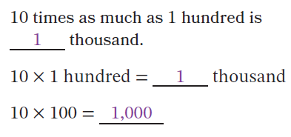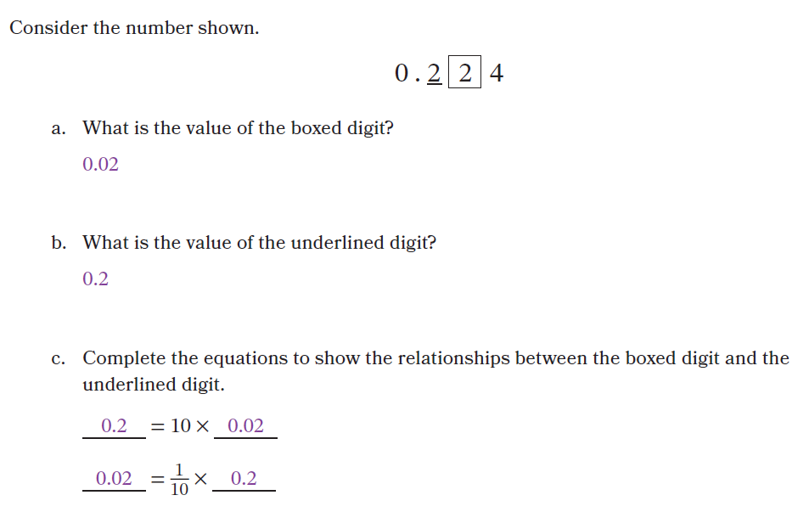
Knowledge Graph Node | Describe the multiplicative relationships between adjacent place value units. | Describe the multiplicative relationships between non-adjacent place value units using standard form notation for whole-number powers of 10. | Write powers of 10 by using whole-number exponents . | Describe the multiplicative relationships between non-adjacent place value units by using exponent notation for whole number powers of 10. | Multiply and divide by powers of 10 and their multiples by using the multiplicative relationships between place value units).
Terminology |  |  | Probably need some terms and definitions here
Mathematical Models
Strategies
Specifications | - Focus is relationship between values of digits (e.g., in 44,975, the value of the 4 in the ten thousands place is 10 as much as the value of the 4 in the thousands place) because of the relationship between adjacent place value units (e.g., 1 ten thousand is 10 times as much as 1 thousand)  - G4: whole numbers only, digit represents 10 times as much as what it represents in the place to its right  - G4: must come after introduction of multiplicative comparison language  - G5: whole numbers and decimals, 10 times as much as to its right, 1/10 as much as to its left (watch sequence with fraction multiplication for language) | - This is a core node for G4 and G5. For G5, states that don’t do exponents in G5 will only get this node. For G5, states that do exponents for powers of 10 in G5 will also get the using exponent notation version. The exponent notation node can point here as a precursor.  - no exponents, use 10, 100, and 1,000 language and notation  - Focus is relationship between values of digits (e.g., in 45,974, the value of the 4 in the ten thousands place is 10,000 as much as the value of the 4 in the ones place) because of the relationship between non-adjacent place value units (e.g., 1 ten thousand is 10,000 times as much as 1 one)  - G4: whole numbers only, 100 times as much, 1,000 times as much, etc., to the right only  - G5: whole numbers and decimals, to the right and left, 100 times as much, 1,000 times as much, 1/10 as much, 1/100 as much, etc. | - Base of 10 only, other bases are in G6 | - This is an additional node for states that do exponents in G5 (they will also get the standard form version of this node for 1/10 as much, etc.)  - exponents, use 10, ${10}^{2}$, and ${10}^{3}$ language and notation  - Focus is relationship between values of digits (e.g., in 45,974, the value of the 4 in the ten thousands place is 10,000 or 10^4 as much as the value of the 4 in the ones place) because of the relationship between non-adjacent place value units (e.g., 1 ten thousand is 10,000 or 10^4 times as much as 1 one)  - G5: whole numbers and decimals, to the right and left, 10^2 times as much, 10^3 times as much | - Standard form (could make exponent form optional)  - Use 10 times relationship between adjacent and non-adjacent place value units to multiply 10, 100, 1,000, etc. or a multiple thereof by 10 and use missing factor equations to divide 10, 100, 1,000, etc. or a multiple thereof by 10 (G4)  - G4: multiply a one-digit whole number and 10 and 100 by 100 and 1,000 and multiples of 100 and 1,000  - G5: Multiply a whole number by a power of 10 and explain patterns in place value (CCSS “number of zeros”)  - G5: Multiply or divide a number, can include decimals, by a power of 10 and explain the patterns in place value (CCSS “placement of the decimal point”)
Leaves to Include
Considerations | - Each place-value unit is 10 times the one to its right; 1 ten is 10 ones, 1 hundred is 10 tens, etc.  - Avoid “move the decimal”. Describe how the value of each digit is determined by position; do not describe the decimal point or digits as physically moving.  - Lean into equations/expanded form  - Place value charts are useful pedagogical tools that can be used to organize work and to scaffold understanding, but they are not “the math”. Favor equations and the number line (or counting array) – these are “the math”  - After students have whole number times a unit fraction, recognize that in a multi-digit number, a digit in one place represents $\frac{1}{10}$ of what the same digit represents in the place to its left |  | - Introduce ${10}^{n}$ notation here, where $n∈N$ |  | - Multiply and divide decimal numbers by powers of 10 and make sense of place value patterns. (connects to multiplication/division stem. Use as a tool for understanding the multiplicative relationship between place value units, that’s the emphasis. Not fluency with “moving the decimal point”)
Required Skills/Cases | - Whole numbers up to 1,000,000—relate the value of digit to the same digit in the place to its right (10 times as much) (G4)  - Whole numbers up to 1,000,000—relate the value of a digit to the same digit in the place to its left (10 times less than or 1/10 as much, depending on instructional sequence) (G5)  - Numbers that include decimals to thousandths—relate the value of a digit to the same digit in the place to its left (10 times less than or 1/10 as much, depending on instructional sequence) (G5) | - Whole numbers up to 1,000,000—relate the value of digit to the same digit in a non-adjacent place to its right (100, 1,000, etc. times as much) (G4)  - Whole numbers up to 1,000,000—relate the value of a digit to the same digit in a non-adjacent place to its left (10 times less than or 1/10 as much, depending on instructional sequence) (G5)  - Numbers that include decimals to thousandths—relate the value of a digit to the same digit in a non-adjacent place to its left (10 times less than or 1/10 as much, depending on instructional sequence) (G5) | - Rename 10, 100, etc. to 1,000,000 as a multiplication expression using factors of 10  - Rename 10, 100, etc. to 1,000,000 in exponential form  - Rename 10^1 to 10^6 as a multiplication expressions using factors of 10  - Rename 10^1 to 10^6 in standard form  - Rename multiplication expression with factors of 10 to exponential form from 10^1 to 10^6  - (Renaming a multiplication expression with factors of 10 directly to standard form is not required; students can move through exponential form) | - Whole numbers up to 1,000,000 and numbers that include decimals—relate the value of digit to the same digit in a non-adjacent place to its right (10^2, 10^3, etc. times as much as) | - Multiply 10, 100, 1,000, 10,000, and 100,000 by 10 (G4)  - Multiply a multiple of 10, 100, 1,000, 10,000, and 100,000 by 10 (G4)  - Multiply 10, 100, 1,000, 10,000 by 100 (G4)  - Multiply a multiple of 10, 100, 1,000, 10,000 by 100 (G4)  - Multiply a one-digit whole number by 100 and 1,000 (G4)  - Multiply a one-digit whole number by multiples of 100 and 1,000 (G4)  - Divide 10, 100, 1,000, 10,000, 100,000, and 1,000,000 by 10 using missing factor equation (G4)  - Divide a multiple of 10, 100, 1,000, 10,000, 100,000, and 1,000,000 by 10 using missing factor equation (G4)  - Divide 1,000, 10,000, 100,000, and 1,000,000. by 100, 1,000, etc. using missing factor equation (quotient ≠10) (G4)  - Divide a multiple of 1,000, 10,000, 100,000, and 1,000,000. by 10 using missing factor equation (quotient ≥100) (G4)  - Multiply a whole number by a power of 10 written in standard form (G5)  - Multiply a decimal by a power of 10 written in standard form (G5)  - Divide a whole number by a power of 10 written in standard form (G5)  - Divide a decimal by a power of 10 written in standard form (G5)  - Multiply a whole number by a power of 10 written in exponential form (G5)  - Multiply a decimal by a power of 10 written in exponential form (G5)  - Divide a whole number by a power of 10 written in exponential form (G5)  - Divide a decimal by a power of 10 written in exponential form (G5)  - Explain the patterns in place value when multiplying or dividing by a power of 10 (G5)
Misconceptions | Just move the decimal point | - Just move the decimal point | - Exponent matches number of multiplication symbols in expression  - Be careful to not overemphasize that for 10^n, n is the number of 0s in standard form and set up a misconception that isn’t true for other bases |  | - Just move the decimal point
Existing Product Reference, if any | EM2 G4 M1 L6 Learn 1  EM2 G5 M1 L1  EM2 G5 M4 L1, L4 | EM2 G4 M1 L6 Learn 2  EM2 G5 M1 L2 | EM2 G5 M1 L3 Learn 1-2 | EM2 G5 M1 L2, but with exponent form  EM2 G5 M4 L5 | EM2 FL G5 M1 L2 (standard form)  EM2 G5 M1 L3 (exponent version)  EM2 FL G5 M4 L6 (standard form)  EM2 G5 M4 L5 (exponent version)
Grade (or Leaf) | 4, 5  Leaf for G3 TX  G5 content is leaf for G4 FL, G3 TX? | 4, 5 | 5 | 5 | 4, 5
Notes related to Standards, Grade, or Leaf | 4.NBT.A.1  5.NBT.A.1  FL.4.NSO.1.1  FL.5.NSO.1.1  TX.3.2B  TX.4.2A  MN.4.3.5.1 | Extends 4.NBT.A.1  Extends 5.NBT.A.1  FL.5.NSO.1.1  TX.3.2B?? | 5.NBT.A.2  (FL, TX exponents in G6) | Extends 5.NBT.A.1 and 5.NBT.A.2  (FL, TX exponents in G6) | 4.NBT.A.1  4.NBT.B.5  5.NBT.A.2  TX.4.4B
Notes for Intervention, Extension, or Optional Activities | Intervention  - Place value disks | Intervention  - Place value disks |  |  | Intervention  - Place value disks  Optional/extension  - Use exponent notation for powers of 10
Additional Notes | Likely 1 instructional period in G4 and 2 instructional periods in G5  Note this might end up being a different organization than EM2 as we put it all together  - Whole numbers, right relationship (G4 core, G3 leaf)  - Whole numbers, left relationship, no 1/10 language (G5 core, G4 leaf)  - Decimals, adjacent right and left relationships, uses 1/10 language (G5) | Likely 1 instructional period in G4 and 2 instructional periods in G5, some might be able to be part of a lesson for other nodes  - Whole numbers, right relationship (G4)  - Whole numbers, right and left relationship (G5)  - Decimals, right and left relationship (G5) | Likely 1 instructional period | Likely 1 or part of 1 instructional period | Likely 1 instructional period in G4 and 2 instructional periods in G5  - Whole numbers (G4)  - Whole numbers (G5)  - Decimals (G5)

